Test Project Module 3 (Packaging)
WSC2011_TP40_M3_actual_EN

Submitted by: Packaging Group
Members: Vivian de Oliveira (BR), Eric Debuiche (FR), Wolfgang Toechterle (IT), Susan de Guzman (AE), Terkko Malm (FI), Hee Min Sa (KR), Prenesh Naidoo (ZA), Teera Piyakunakorn (TH)
Member Country: FR, IT, AE, FI, KR, ZA, TH
Time 6

Introduction to test project documentation

Contents
This Test Project proposal consists of the following documentation/files:
- WSC2011_TP40_M3_actual_EN.doc Project Brief
- WSC2011_TP40_BR_CC01_EN.pdf (sample of ZéCar)
- WSC2011_TP40_BR _EN.txt (text file for the package, sticker, small manual)
- WSC2011_TP40_BR_CC02_EN.eps (logo of the manufacturer)
- WSC2011_TP40_BR_CC03_EN.eps (logo of the distributor)
- WSC2011_TP40_BR_CC04_EN.zip (file of clip arts)
- WSC2011_TP40_BR_CC05_EN.zip (folder of images)
- WSC2011_TP40_BR_CC06_EN.eps (barcode)

Introduction
Project : Design of a package, a sticker and a brief manual.

Description : You were hired to create the packaging for the Robot ZéCar. This robot is one of the creations of the designer Chico Bicalho, and was created with the intention of promoting a reforestation project in a public area of 200.000m² (50 acres) in the Valle Florido in Petropolis, State of Rio de Janeiro, Brazil. The area began to be cleared in the early 70's and now the soil is degraded and covered with grass.
Designer Chico Bicalho mobilized local people to help reforest the area, but for lack of money the initiative has not had much success. In 2001, Guga Casari and Chico Bicalho developed a toy called ZéCar. It is distributed by the company Kikkerland Design Inc. of New York, The entire royalties from the sale of this product will go fully to the project Mil Folhas (Thousand Leaves).
Thousand Leaves Project (Mil Folhas) is supposed to be completed by the year 2016. By then, approximately 300,000 native tree seedlings and more than 150 different species from the Atlantic and are expected to be planted. In addition, two important collectors of bromeliads are preparing significant donations to the project, which will enrich the forest with more than 500 rare species of bromeliads, many of which, are native to the region. More than reforestation, Thousand Leaves Project will establish a genetic bank of trees, which will be a headquarters for the collection of seeds, new projects and reforestation.
Your challenge is to create a package for ZéCar, a sticker for the car and a brief manual for reforestation. The sticker and the packaging should deliver the message to the target audience that, by purchasing the toy, he is not only helping to reforest but he is part of a big environmental project.

The ZéCar is a robot that does not use batteries. This little stainless steel car has an internal flywheel to store energy that is enough to roll or climb over small obstacles for a certain amount of time.
As an environmentally friendly person, the toy designer made only wind-up toys to amuse, entertain and to make people conscious that every little insect or bug is an important part of the Eco-system.

Target market : Adults aged from 20 to 40 who enjoy nature, museums and sculptures.

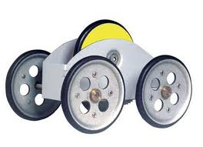
Sample the ZéCar.

Description of project and tasks

TASK 1
Design of the package

• Dimensions: must not exceed one A3 sheet or 297mm x 420mm (format flat)
• The package must have two glue points or two glue areas
• Include Package Text on the package (WSC2011_TP40_BR _EN.txt)
• Include the manufacturer’s logo on the package (WSC2011_TP40_BR_CC02_EN.eps)
• Include the Mil Folhas logo on the package (TP40_40CA_PRE_04_EN.eps)
• Use any of the supplied images to design your package or create your own illustration (bitmap or vector) (WSC2011_TP40_BR_CC04_EN.zip) (WSC2011_TP40_BR_CC05_EN.zip)
• Include the barcode in a white background on the side or on the bottom of the box; do not resize it and make sure it’s 100% black (WSC2011_TP40_BR_CC06_EN.eps)
• Trapping must be used if necessary

Technical specifications
Dimensions : 297mm X 420 mm (A3 flat)
Bleed : 3 mm
Colours : CMYK + 1 dieline
Printing : printed on one side only / web offset printing
Output : ICC profile in PDF: Web Coated FOGRA28 / Total ink 300%
Screening/halftone screen : 150 LPI
Greyscale and colour images resolution : from to 280 to 320 PPI
Bitmap images resolution : from 800 to 1200 PPI
Trapping : 0.35 pts

You must deliver
• 1 final composite PDF/X-4:2008 file (including die line as separate spot colour with overprint and using maximum of 1 pt. weight of the stroke, bleed, fold lines, crop marks and specified output profile)
• 1 final folder for archiving (including native files, fonts, linked images and the composite PDF file)
• 1 final package in 3D mock-up

TASK 2
Design of the sticker
• Design one (1) sticker for a person to place on their own automobiles (for marketing) and dimension should fit in the package (you can use transparent material or white paper)
• Use any of the supplied images to design your sticker or create your own illustrations
• Include the Sticker Text on the sticker (WSC2011_TP40_BR _EN.txt)
• Include the manufacturer’s logo on the sticker (WSC2011_TP40_BR_CC02_EN.eps)

Technical specifications
Dimensions : Maximum format is 90mmX100mm, that will fit into the package
Bleed : 5 mm
Colours : 4 spot colours and one dieline
Printing : printed on one side only / flexography printing
Output ICC profile in PDF : Coated FOGRA27
Screening/halftone screen : 100 LPI
Printing system : Flexography printing
Greyscale and colour images resolution : from to 100 to 150 PPI
Bitmap images resolution : from 400 to 600 PPI
Trapping : no trapping

You must deliver
• 1 final composite PDF/X-4:2008 file (including bleed, die line, and specified output profile)
• 1 final folder for archiving (including native files, fonts, linked images and the press ready PDF file)
• 1 composite printout of 100% on A4

TASK 3
Design of brief manual of reforestation
• Design a small Manual that will be included inside the package
• Use any of the supplied images to design your manual or create your own illustrations
• Include Manual Text on the manual (WSC2011_TP40_BR _EN.txt)
• Include the manufacturer’s logo on the Manual (WSC2011_TP40_BR_CC02_EN.eps)

Technical specifications
Dimensions : A3 maximum flat
Bleed : 5 mm
Colours : CMYK
Printing : sheetfed offset printing
Output ICC profile in PDF : Coated FOGRA27 / Total ink 350%
Screening : 150 LPI
Greyscale and colour images resolution : from to 280 to 320 PPI
Bitmap images resolution : from 800 to 1200 PPI
Trapping : No trapping

You must deliver
• 1 final composite PDF/X-4:2008 file (all marks)
• 1 final folder for archiving (including native files, fonts, linked images and the press ready PDF file)
• 1 final untrimmed composite printout
• 1 final trimmed and assembled manual – Mockup 3D

Instructions to the competitor
About image marking for all tasks:
The final resolution, colour mode and file formats of your images will be evaluated in the press ready PDF files. The JPG file format is NOT ACCEPTED for images;
only the following saving format files are acceptable: .tif / .eps / .ai / .psd / .dcs

Equipment, machinery, installations and materials required
• No specific information

Marking scheme
Subjective 10 marks
Section A - Creative process – 2 Marks
- Idea and originality (package, sticker, manual) 1.00
- Understanding the target market (package, sticker, manual) 0.50
- Unity and relationship (package, sticker, manual) 0.50

Section B - Final design – 8 Marks
- Quality of the visual composition (package, sticker, manual) 3.00
- Impact of the design (package, sticker, manual) 1.00
- Quality of the typography for the package, sticker, manual) 0.25
- Suitability of font used (package, sticker, manual) 0.50
- Quality of the formatting of typography (package, sticker, manual) 0.25
- Suitability of the colour choice (package, sticker, manual) 1.00
- Quality of the colours used (package, sticker, manual) 1.00
- Quality of the mounted presentation (package and manual) 1.00

Objective 15 marks
Section C - Computer usage – 4 Marks
- Resolution of images (package, sticker, manual) 1.00
- Colour mode of the barcode 0.50
- Images dimensions (Barcode) 0.25
- Final dimension of layout (package, sticker, manual) 1.25
- All required text is present (package, sticker, manual) 0.50
- All required elements are present (package, sticker, manual) 0.50

Section D - Manual abilities (Total of 2 Marks)
- Mounting printouts for presentation (sticker and manual) 0.75
- Assembling in 3D package and manual 1.25

Section E - Knowledge of the printing industry – 4 Marks
- Bleed value applied in PDF (package) 1.50
- Trapping value applied in Package 0.50
- Colour mode (packaging, sticker, manual) 0.50
- Overprinting applied in dieline (sticker and package) 0.50
- Dieline applied as required (package, sticker) 1.00

Section F - Saving and file format – 5 Marks
- All files saved in the correct format (package, sticker, manual) 0.75
- ICC profile applied (package) 0.75
- ICC profile applied (sticker, manual) 0.50
- Saving in the specified PDF format (package, sticker, manual) 2.00
- Final production folder saved as required (package, sticker, manual) 1.00

other
• WSC2011_TP40_BR_CC01_EN.pdf (sample of ZéCar)

• WSC2011_TP40_BR _EN.txt (text file for the Package design)

• WSC2011_TP40_BR _EN.txt

Package Text

Collector´s Item
ZéCar Windup
Robot Mécanique

Instructions and Maintenance

How to Wind Up ZéCar:

Hold it with one hand and turn the brass weight clock wise until it get stocked (do not force it)

Keep holding the brass weight to avoid it to unwind.

Put it carefully on the floor or on a surface with or without small obstacles.

Release the brass weight and the toy and enjoy its performance.

Repeat the steps once the toy stops performing.

Every once in a while, a bit of oil spray lubricant will keep the engine in top shape.

Blog: www.kritteria.com
www.kikkerland.com
patent pending
kikkerland design INC. 423-427 Wst 12TH ST. New York, NY 10027 USA

Sticker Text

ZéCar
Helps the RIO de Janeiro Reforestation

Manual Text

How to Plant a Tree
1. Dig a hole at least twice the width of the root so it can grow. Take the tree container that is, carefully cut the roots broken and slowly remove the plant from the bag or vessel.
2. Place the tree in the planting hole. Always lift the tree by the root ball and never by the trunk. Spread the tips of the root out. Avoid planting the tree too deep. Make sure the soil line of the young tree is higher than the surface of the surrounding hole.
3. Throw some ground in the planting hole. Check the depth and adjust if necessary. Confirm that the plant is straight. Fill the hole gently but firmly. Pat the soil around the base of the root.
4. It is not recommended to apply fertilizer at planting time. Ague the new plant thoroughly with a watering can is not strong enough to settle the soil. Do not shake the tree. The faster it can stand alone, the faster it will become strong.
5. Provide follow up care. Protect the tree from pests and diseases by removing nearby plants that might affect it. Remove weeds as they compete with tree roots for moisture and nutrients. Protect the tree from destruction by animals.
6. If possible, plant the trees so they do not compete with moisture and nutrients from the soil and the growth of branches is encouraged. Beware of drought and provide water if necessary, especially during the first month. Watch out for yellowing of leaves. Always maintain good air circulation by cutting branches to grow better and to prevent pests and diseases.

• WSC2011_TP40_BR_CC02_EN.eps (logo of the manufacturer)



• WSC2011_TP40_BR_CC03_EN.eps (logo of the distributor)



• WSC2011_TP40_BR_CC04_EN.zip (folder of clip art)

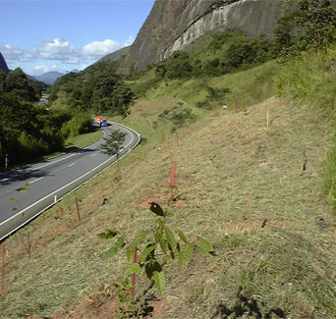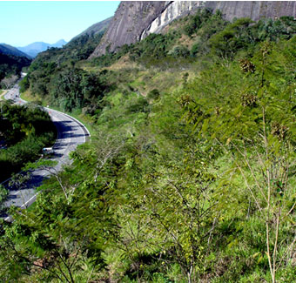
before the project after the project

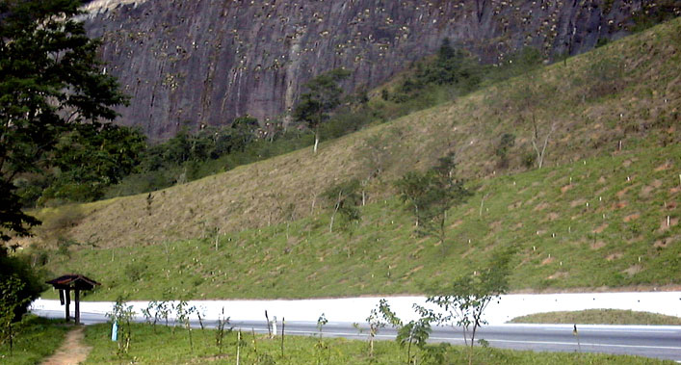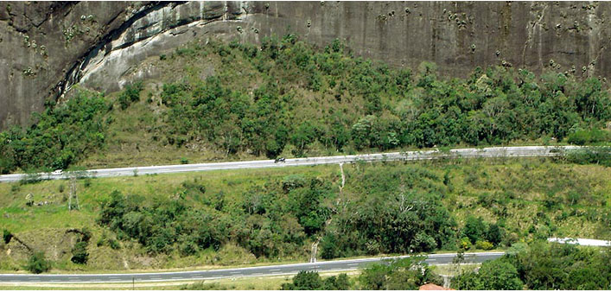
before the project after the project

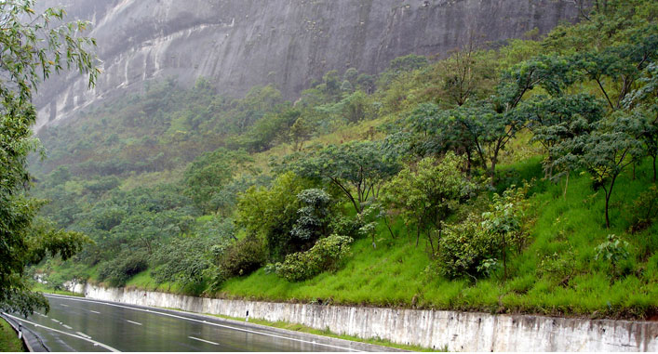
before the project after the project

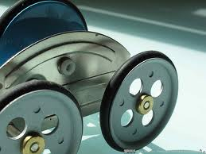

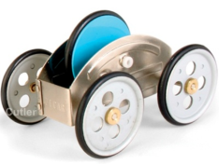

• WSC2011_TP40_BR_CC06_EN.eps (barcode)



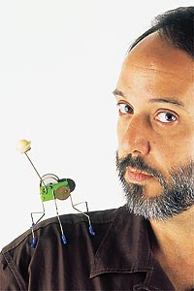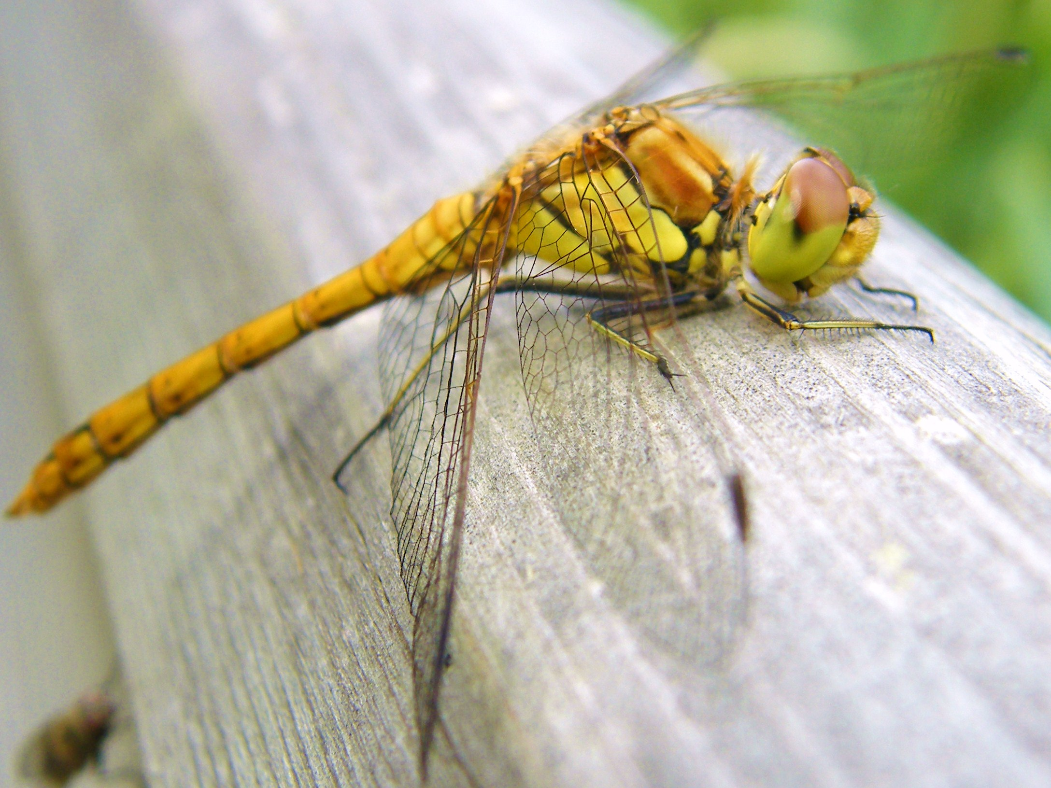

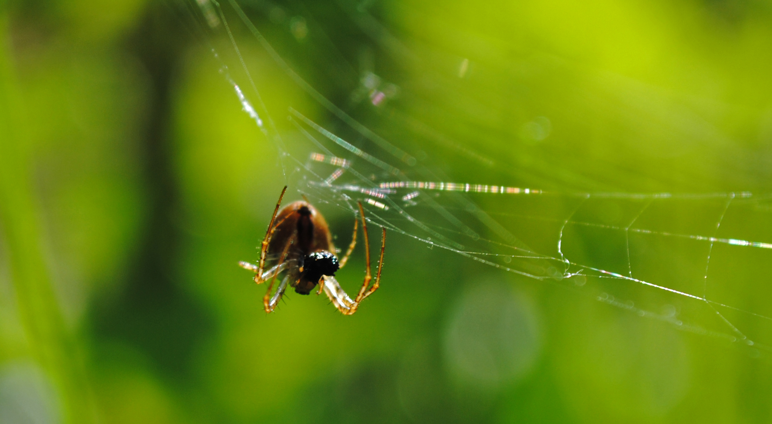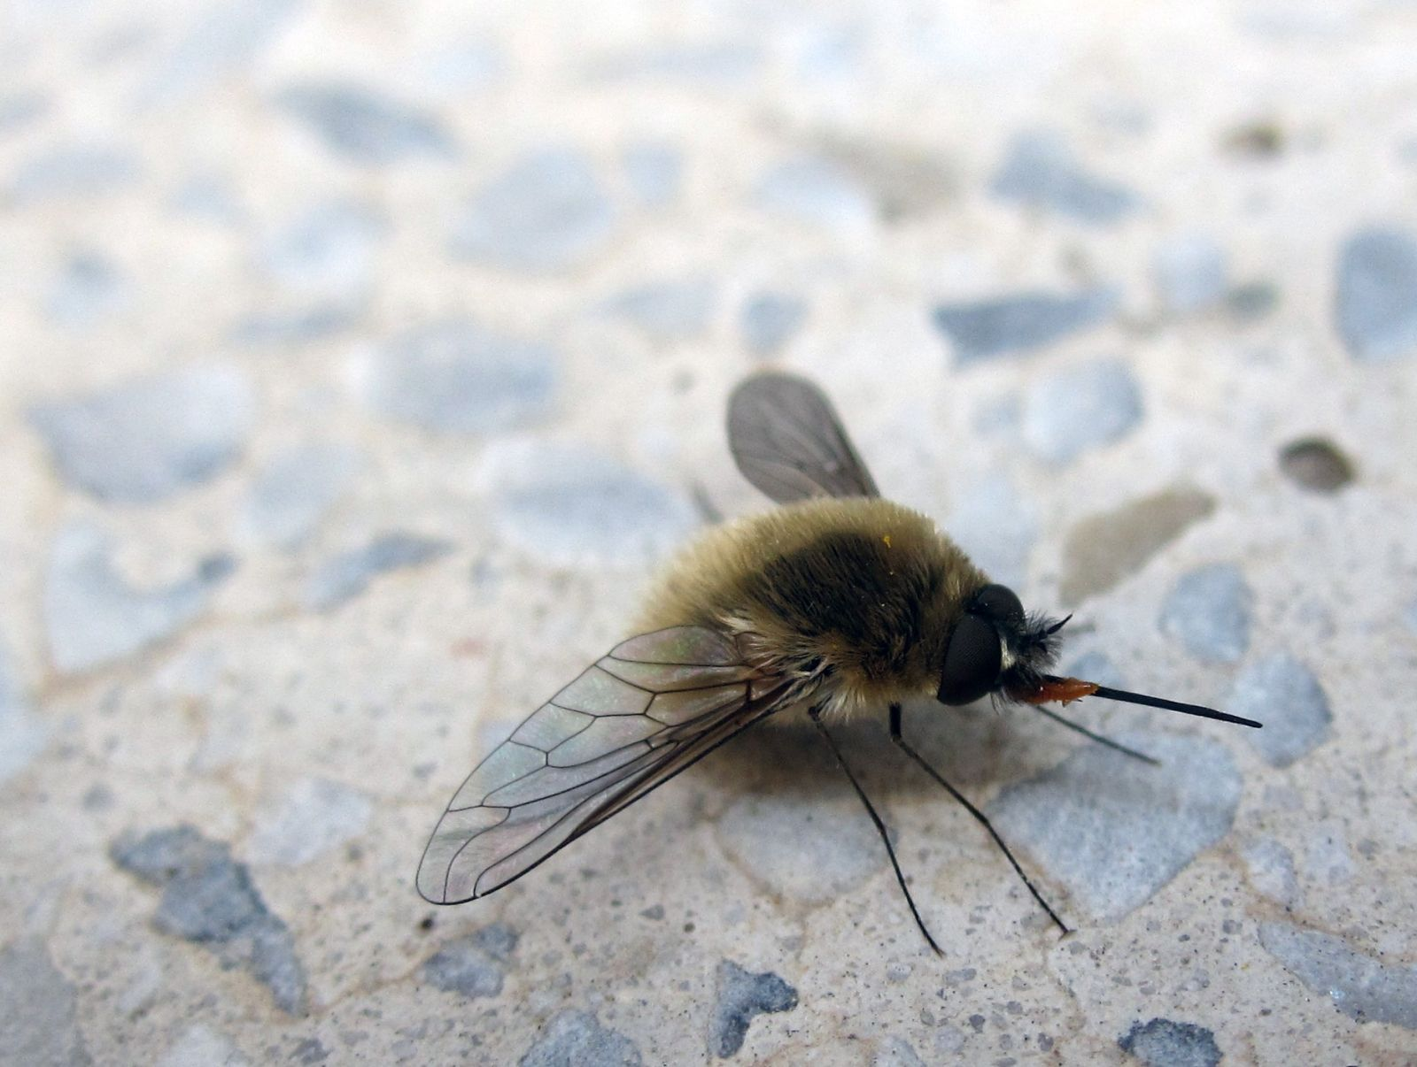

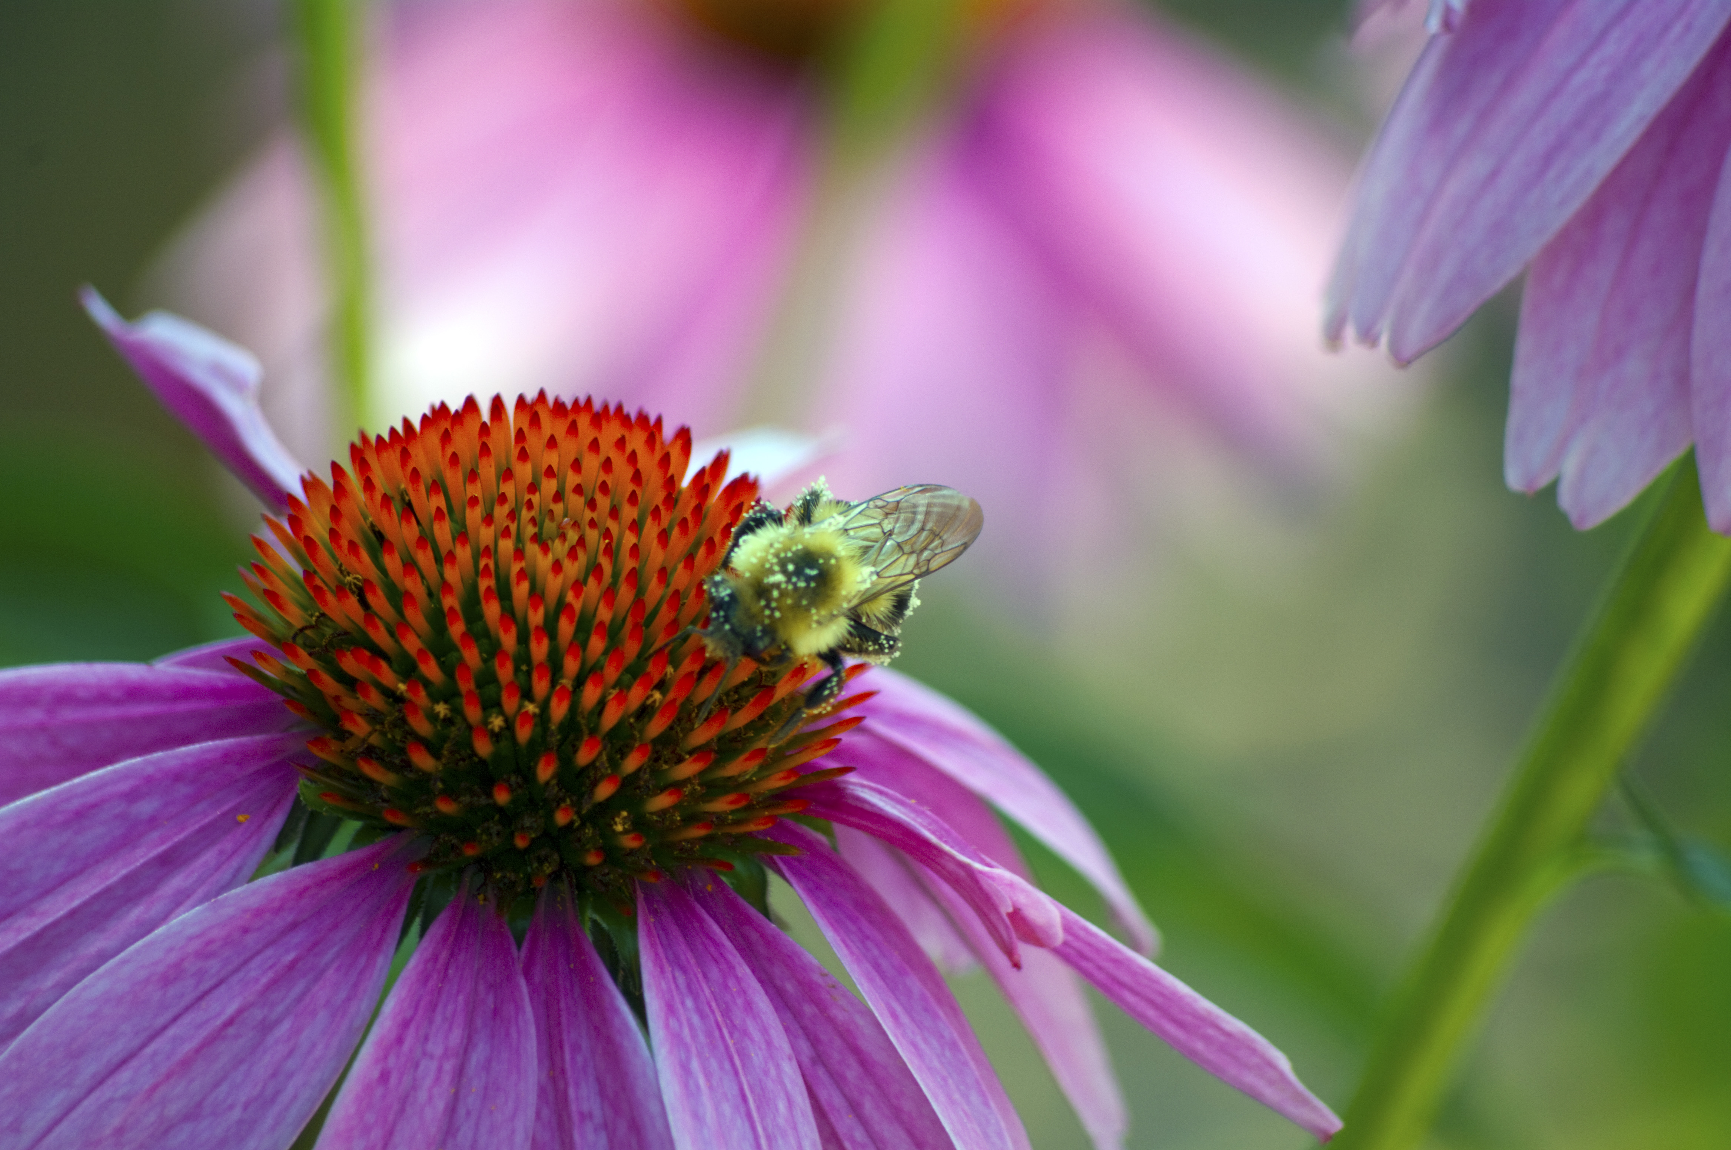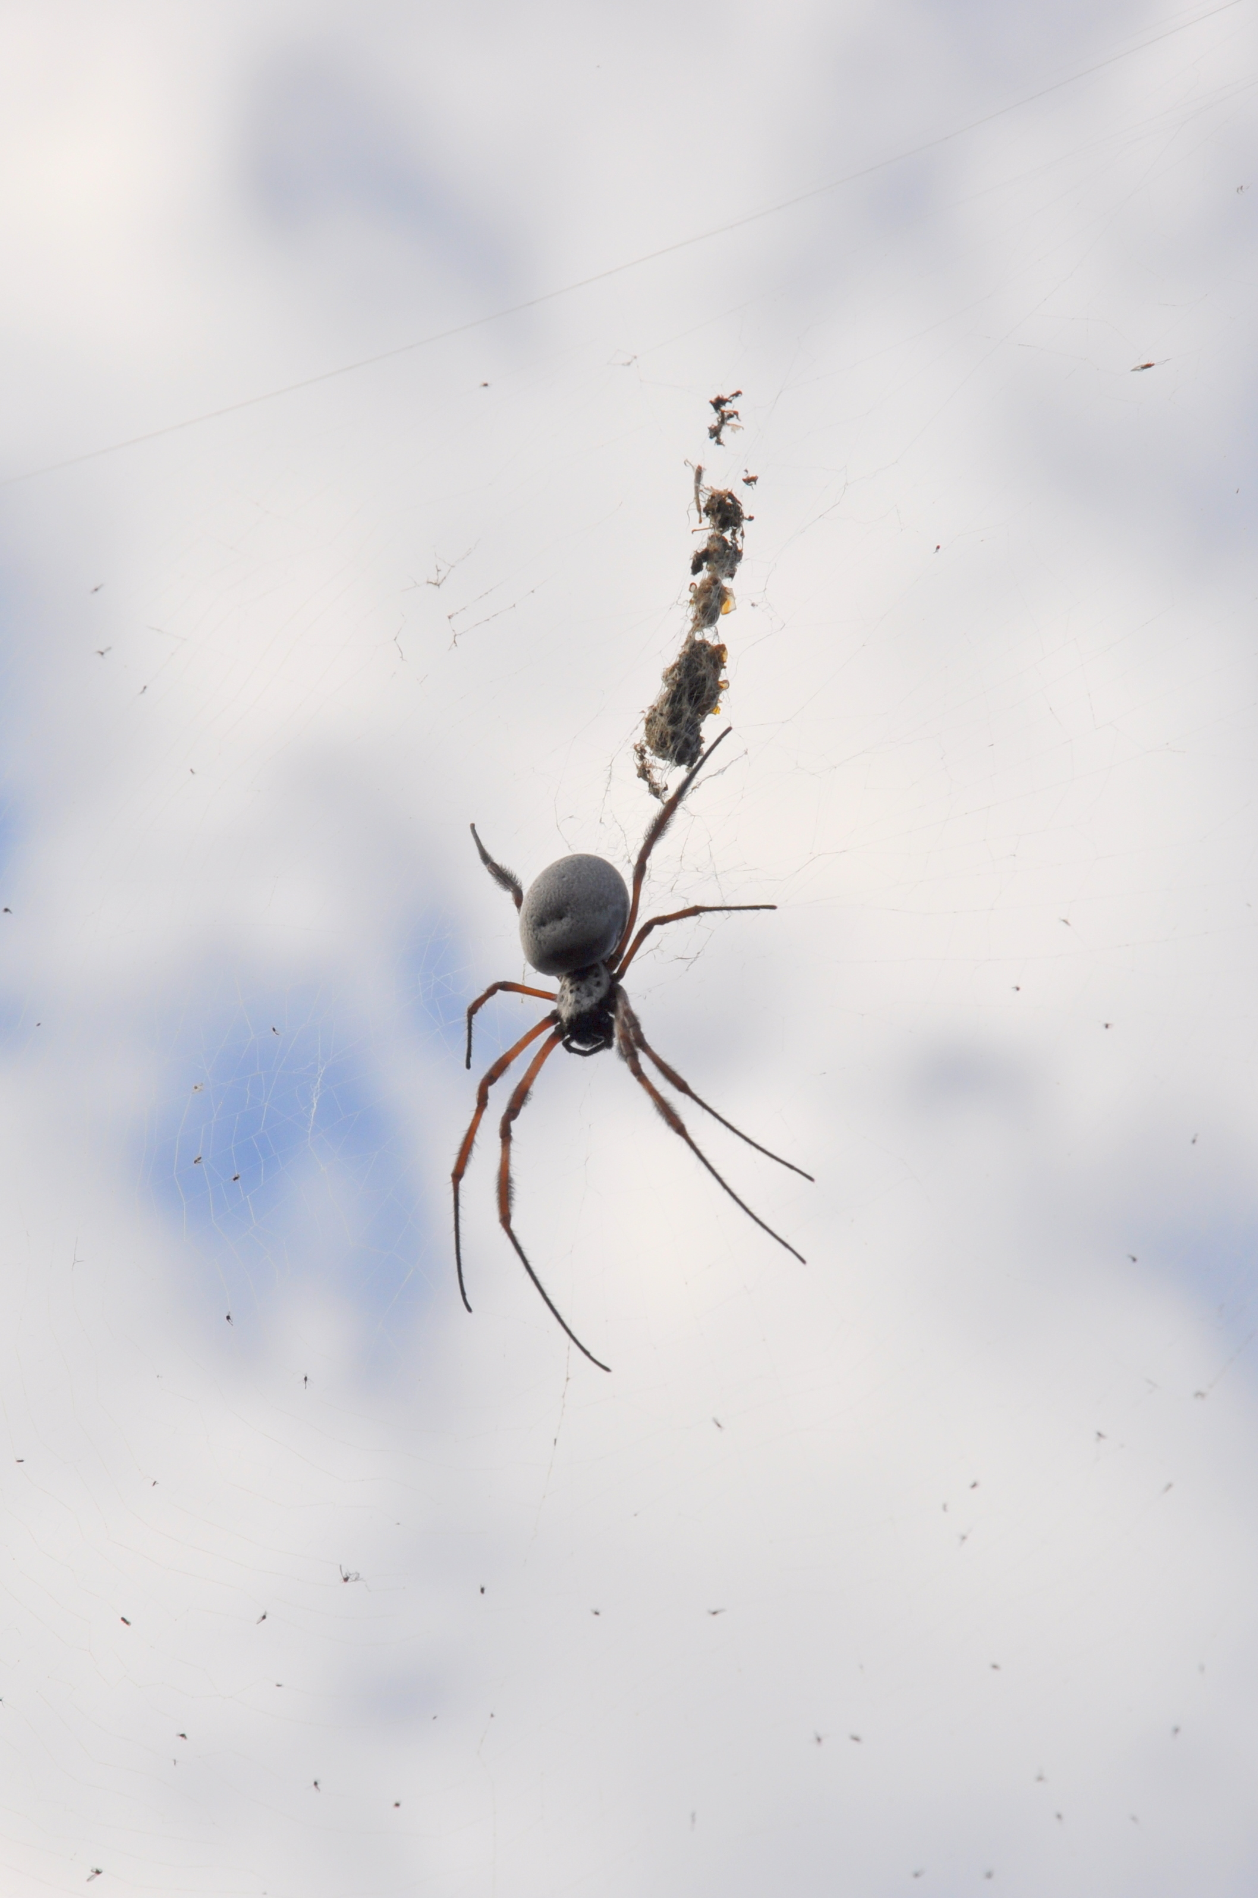

Glossary

Bromeliads are members of a plant family known as Bromeliaceae (bro-meh-lee-AH-say-eye). The family contains over 3000 described species in approximately 56 genera. The most well known bromeliad is the pineapple. The family contains a wide range of plants including some very un-pineapple like members such as Spanish Moss (which is neither Spanish nor a moss). Other members resemble aloes or yuccas while still others look like green, leafy grasses.
In general they are inexpensive, easy to grow, require very little care, and reward the grower with brilliant, long lasting blooms and ornamental foliage. They come in a wide range of sizes from tiny miniatures to giants. They can be grown indoors in cooler climates and can also be used outdoors where temperatures stay above freezing. Source: http://www.bsi.org/brom_info/what.html

